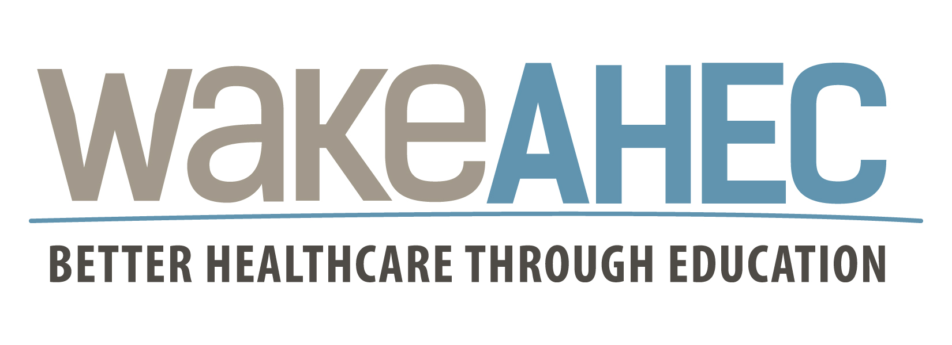

Insert Name
Participant’s Name

has attended the continuing medical education activity

The Carolinas Anesthesiology 2019: Quality in Anesthesia

(Event #59719)

September 13-15, 2019

The Omni Grove Park Inn
Asheville, NC

CME Credit
The Wake Area Health Education Center designates this live activity for a maximum of 11.0 AMA PRA Category 1 Credits™. Physicians should claim only the credit commensurate with the extent of their participation in the activity.
Additional Credit
Other health professionals will receive a certificate of attendance from an approved AMA PRA Category 1 Credit™ activity. These certificates are accepted by the NC Boards for Certified Anesthesiologist Assistants and critical care specialist. License requirements are subject to change. Wake AHEC recommends that participants contact their licensing boards for specific questions.

Continuing Education Units (CEUs)
Wake Area Health Education center will provide 1.1 Continuing Education Units to participants upon completion of this activity. No partial credit will be given.

Contact Hours
Wake Area Health Education Center will provide up to 11.0 contact hours to participants upon completion of this activity.
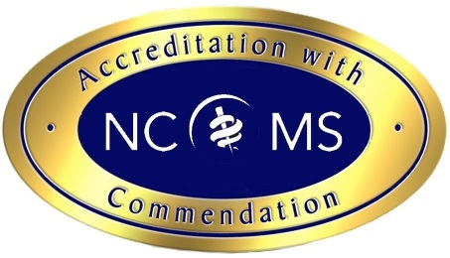
Accreditation Statement
This activity has been planned and implemented in accordance with the accreditation requireme requirements and policies of the North Carolina Medical Society (NCMS) through the joint joint provi providership of Wake Area Health Education Center and the North Carolina Society of Anesthesiologists. The Wake Area Health Education Center is accredited by the NCMS to provide continuing medical education for physicians.

Declaration:
General Sessions:
On Friday Morning, September 13, 2017, I attended enter # of hrs hours of this course. (Up to 3.75 max)
On Friday Afternoon, September 13, 2017, I attended enter # of hrs hours of this course. (Up to 2.5 max)
On Saturday, September 14, 2017, I attended enter # of hrs hours of this course. (Up to 3.35 max)
On Sunday, September 15, 2017, I attended enter # of hrs hours of this course. (Up to 1.40 max)



Sandie M. Coleman, MAEd
Wake AHEC CME Associate Director
September 15, 2019

