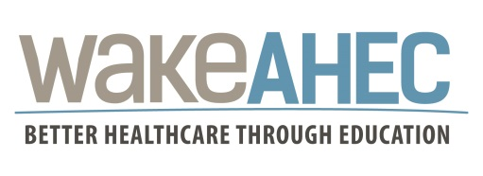

Insert Name
Participant’s Name

has attended the continuing education activity

Circle of Care: The importance of Pre & Interconception Health Care
(Event #57761)

October 23, 2018

This program has been approved for the following credits:

Continuing Education Units (CEU)
Wake Area Health Education Center will provide 0.1 Continuing Education Units
to participants upon completion of this activity.
Participants must attend 100% of this activity.
Partial CEU credit will not be awarded.

Contact Hours
Wake Area Health Education Center will provide up to 1.0 Contact Hours to participants upon completion of this activity.

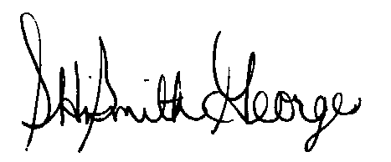

October 23, 2018

Sherika HiSmith George, MPH, BSN, RN Date
Associate Director, Nursing
Wake AHEC

