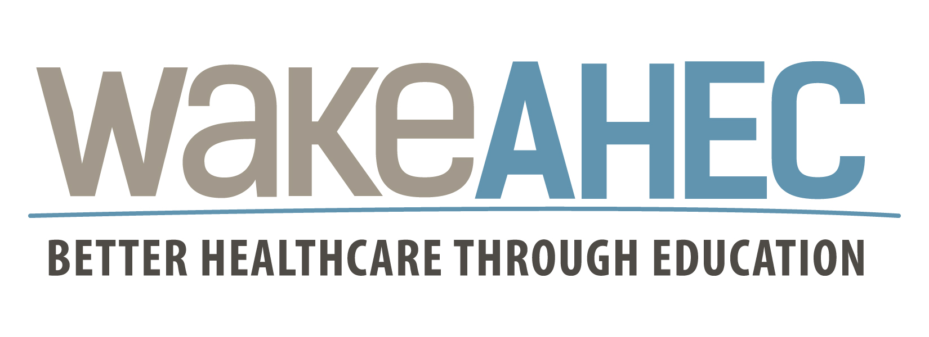

Insert Name
Participant’s Name

has attended the continuing education activity

Evidence-Based Tobacco Use Cessation
Counseling Methods and Best Practices Update 2018

(Event # 57221)

William F. Andrews Conference Center, Raleigh, NC

November 26, 2018
This program has been approved for the following credits

CME Credit
The Wake Area Health Education Center designates this live activity for a maximum of 3.0 AMA PRA Category 1 Credits™. Physicians should claim only the credit commensurate with the extent of their participation in the activity.

Nursing Credit
3.00 CNE Contact Hours
Wake AHEC, Nursing Education, is an approved provider of continuing nursing education by the North Carolina Nurses Association, an accredited approver by the American Nurses Credentialing Center’s Commission on Accreditation.
Participants must attend 100% of this activity. Partial CNE credit will not be awarded.

NCRCB Credit
Approved by the NC Respiratory Care Board for 3.0 hours of CE. Approval # 183498

NCSAPPB Credit
NC Substance Abuse Professional Practice Board Credit: This program has been approved for 3.0 hours of SS (ND) (EBT) by the North Carolina Substance Abuse Professional Practice Board. Approval # 18-464-S.

Continuing Education Units (CEU)
Wake Area Health Education center will provide 0.3 Continuing Education Units to participants upon completion of this activity.
Participants must attend 100% of this activity. Partial CEU credit will not be awarded.

Contact Hours
Wake Area Health Education Center will provide up to 3.00 contact hours to participants upon completion of this activity.

AAPA Credit
AAPA accepts certificates of participation for educational activities certified for AMA PRA Category 1 Credits™ from organizations accredited by ACCME or a recognized state medical society. Physician assistants may receive a maximum of 3.0 hours of Category 1 credit for completing this program.
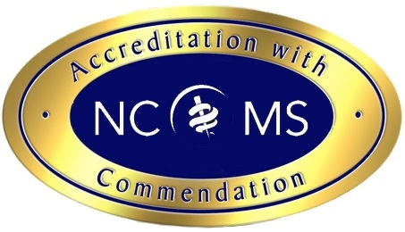
Accreditation Statement
The Wake Area Health Education Center is accredited by the NCMS to provide
continuing medical education for physicians.
Declaration:
On November 26, 2018, I attended enter # of hrs hours of this course. (Up to 3.00 hours)

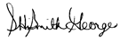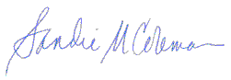

Sherika HiSmith George, MPH, BSN, RN Sandie Coleman, MAEd
Wake AHEC Associate Director, Nursing Wake AHEC Associate Director, CME
11/26/18 11/26/18

