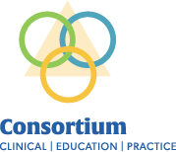
Facilitating Success, together.

Goal: Complete the core orientation one time for the academic year 2025-2026.

- You will need to establish a MYAHEC account if you don’t already have one by following the instructions below:
Instructions to set up a MyAHEC account:
  - Create a My AHEC account on Wake AHEC website and fill out the required fields.
  - Click the “Create Account” button at the bottom of the screen.
  - An account verification link will be sent to your email address. Click the verification link to complete the MyAHEC account setup process. (Note: make sure to check the junk or SPAM folder if you do not see the email).
- Once you have a My AHEC account, you will need to register for the Core Orientation. You can only register once. See step 3 for finding the course if you registered previously.
Visit the Triagle CCEP page to find the registration link
Refresh your webpage.
  - On the left side of the page under For Students – Tools and Resources, click the second item, Register for Core Orientation.
  - Click the Register button
  - Check your information and click Continue.
  - Fill out the form. Leave the first 3 preselected items checked, check the box under Credit for Certificate of Completion, select one of the options under “How did you hear about this event?” and check the box to agree to the cancellation policy.
  - Click Register
- Finding the course once you’ve registered:
  - Sign in to your My AHEC account
  - Click the My Courses And Events icon.
  - Find the Core Orientation in the resulting list.
  - Click the button to Access Course Materials to the right of the course title.
  - Click Open
  - Click Start Learning Now and follow the instructions in the course. You will need to read and/or download each item and watch the entire video. Use the Next Lesson button to go to the next item in the course. Once you have completed everything according to the instructions in the course, your certificate of completion will be available for download using a pop-up window with a link at the time of completion, or by clicking the Download Certificate button at the top of the course screen as shown below. This only appears if you have completed everything in the course.

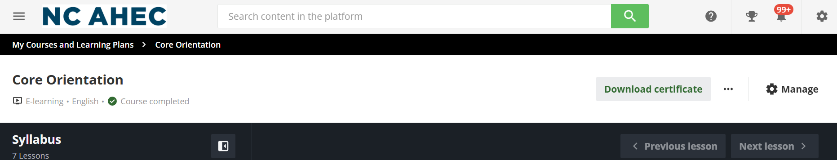

Updates to the 2025-2026 Core Orientation Presentation:

Resource Guide that lists all links included in the Core Orientation. New links and videos are only accessed from the Resource Guide provided. Test questions from this information is included at the end of the presentation.

